Skeleton Based Human Action Recognition
UCS761 Deep Learning Project Report
Submitted by:
102316091 – Sahil Kumar
102316104 – Aashish Sharma
102316106 – Chaitanya Singh Chouhan
102316108 - Naman Jain
BE Third Year – CSE
Group: P1N (3P14)



Submitted to:
Dr. Reeta
Thapar Institute of Engineering and Technology, Patiala

May 2026

Table of Contents
- Introduction…………..……………………………………………………………1
- Literature Review…………………….……………………………………………1
- Methodology……………………….……………………………………………...3
- Implementation Details……………....……………………………………………4
- Results and Analysis……………………………………………………………....5
- Conclusion…….……………………..……………………………………………7
- References…………………………………………………………………………8

Introduction
Human Action Recognition (HAR) is a key problem in computer vision with applications in surveillance, healthcare, human–computer interaction, and sports analytics. Its goal is to automatically identify human activities from visual data. Traditional RGB-based approaches, while effective, are often sensitive to background noise, lighting conditions, and viewpoint variations. To overcome these limitations, skeleton-based representations have gained prominence due to their robustness and efficiency.
Skeleton-based HAR models represent the human body as a set of joints connected in a structured form, capturing spatial and temporal motion patterns while discarding irrelevant visual details. This abstraction reduces computational complexity and improves invariance to environmental changes. With advancements in pose estimation techniques, obtaining accurate skeletal data has become more feasible, further driving research in this domain.
However, several challenges persist. Real-world skeleton data is often noisy due to pose estimation errors, leading to unstable joint trajectories. Additionally, distinguishing between actions with similar motion patterns remains difficult. Variations in execution speed, viewpoint, and individual differences further complicate the task. Addressing these issues requires models capable of learning robust spatial-temporal features while handling noise effectively.
Recent approaches leverage deep learning techniques such as Graph Convolutional Networks (GCNs) and Transformers to model joint relationships and temporal dependencies. These methods, along with data augmentation and improved feature learning strategies, have significantly enhanced performance.
This project aims to develop a reliable skeleton-based HAR system that balances accuracy, robustness, and computational efficiency, making it suitable for real-world applications.

Literature Review
Skeleton-based human action recognition (HAR) has evolved significantly in recent years, driven by the need for robustness in real-world environments, improved generalization, and richer semantic understanding of human motion. Traditional approaches primarily relied on handcrafted features or fixed graph structures, but recent work has shifted toward data-driven, adaptive, and multimodal learning paradigms.
A major emerging direction is the move toward universal and open-vocabulary recognition. Li et al. propose a Transformer-based framework that introduces a unified skeleton representation capable of handling heterogeneous input formats while aligning motion dynamics with textual semantics [1]. This approach departs from closed-set classification and instead enables models to generalize across unseen action categories. The incorporation of motion-text alignment further bridges the gap between vision and language, positioning skeleton-based HAR within the broader context of multimodal learning.
Another important trend is the adoption of self-supervised learning to address the scarcity of labeled data. Zhang et al. introduce a hybrid framework combining topology-masked prediction with contrastive learning [2]. By masking parts of the skeleton graph and predicting them while simultaneously maximizing agreement between augmented views, the model learns robust spatial-temporal representations. This dual strategy effectively captures both structural dependencies and motion dynamics, improving generalization without heavy reliance on annotations.
Improving class separability and representation quality has also been explored through generative modeling techniques. Liu et al. propose an Active Generation Network (AGN), which includes an Action Generation Module and a Boundary Optimization Module [3]. The key idea is to synthesize discriminative skeleton patterns that enhance inter-class boundaries. This approach directly tackles the issue of overlapping motion patterns across similar actions, leading to improved classification performance.
Graph-based architectures remain central to skeleton-based HAR, with ongoing refinements to better model joint relationships. Tan et al. introduce PCCTR-GCN, which integrates pose correction mechanisms with channel topology refinement [4]. The pose correction module mitigates noise from imperfect pose estimators, while the refined graph convolution adapts channel-wise dependencies dynamically. This combination enhances feature extraction and stability, particularly in noisy real-world scenarios.
Handling noise and instability in skeletal data is another critical research focus. Wang et al. propose the “Action Jitter Killer,” a joint noise optimization cascade designed to suppress temporal fluctuations in joint coordinates [5]. By explicitly modeling and reducing jitter, the method significantly improves recognition accuracy in unconstrained environments where pose estimation is unreliable.
Complementing model-centric improvements, data-centric approaches have also gained traction. Cormier et al. emphasize the importance of realistic data augmentation, demonstrating that synthetic perturbations mimicking real-world noise can substantially enhance model robustness [6]. Their work highlights that improving training data quality is as crucial as architectural innovation for deployment in practical settings.
Finally, researchers have begun to address the inherent limitation of skeleton-only representations by incorporating contextual information. Xu et al. propose an object-augmented framework (OA-SAR) that integrates interactions between humans and surrounding objects [7]. This is particularly useful for distinguishing actions with similar poses but different semantics (e.g., “drinking” vs. “brushing teeth”). The inclusion of object cues enriches the representation and improves discriminative capability.
In summary, recent advancements in skeleton-based HAR are characterized by three key shifts: (i) from closed-set to open-vocabulary and multimodal learning, (ii) from supervised to self-supervised and generative representation learning, and (iii) from clean laboratory data to robust real-world deployment. Future research is likely to further integrate language, context, and cross-modal reasoning while continuing to address challenges such as noise robustness and generalization.

Methodology
Model Architecture
- Type of model: Graph Convolutional Network (GCN) with Channel-wise Topology Refinement (CTR-GCN). The model is implemented as a 2-stream ensemble, with one network trained on Joint Stream (raw coordinates) and another on Bone Stream (vector differences between joints). Final predictions combine outputs through Late Fusion with 1:1 weighting.
- Layers used: Three main stages of GCN and TCN blocks:
  - Stage 1: AdaptiveGCN (2-3 channels to 64) + MultiScaleTCN (64 to 64);
  - Stage 2: AdaptiveGCN (64 to 128) + MultiScaleTCN (128 to 128, stride=2);
  - Stage 3: AdaptiveGCN (128 to 256) + MultiScaleTCN (256 to 256, stride=2). Global average pooling followed by FC layer mapping to 60 output classes.
- Activation functions: ReLU activation functions are used throughout, specifically after each BatchNorm layer in AdaptiveGCNBlock and MultiScaleTCN modules.
- Loss function: CrossEntropyLoss is used as the standard multi-class classification loss function, applied to both Joint and Bone streams during training.
- Optimizer: Stochastic Gradient Descent (SGD) with Nesterov momentum (0.9), weight decay (1e-4), and Nesterov Accelerated Gradient enabled. CosineAnnealingLR scheduler decays learning rate from 0.1 to near zero over training period.

Workflow
- Data – NTU RGB+D (NTU-60) dataset with ~56k sequences, 60 action classes, using Cross-View split (≈37k train, ≈19k test) with skeleton joints and temporal sequences.
- Preprocessing – Temporal normalization to 64 frames, skeleton centralization, Gaussian noise augmentation, and extraction of bone features to form a dual-stream input.
- Training – Two separate streams (joint and bone) trained for 60 epochs using SGD with Nesterov momentum and cosine annealing; best model selected via validation accuracy.
- Testing – Evaluation performed on unseen test split using late fusion, where logits from both streams are combined with equal weighting for final prediction.
- Evaluation – Metrics include Top-1 accuracy (~95.76%), precision, recall, F1-score per class, and confusion matrix analysis to identify misclassification patterns.

Implementation Details
Training & Optimization Parameters
Table 1: Training and Optimization Hyperparameters of the Proposed Model
Parameter | Value | Description
Optimizer | SGD | Stochastic Gradient Descent
Learning Rate | 0.1 | Initial learning rate
Momentum | 0.9 | SGD momentum factor
Nesterov | True | Enables Nesterov Accelerated Gradient
Weight Decay | 1e-4 | L2 regularization
LR Scheduler | CosineAnnealingLR | Learning rate decay strategy
T_max | 60 | Max iterations for cosine schedule
Epochs | 60 | Training iterations per stream
Batch Size | 64 | Samples per batch
Loss Function | CrossEntropyLoss | Multi-class classification loss

Data & Input Parameters
Table 2: Data and Input Configuration Parameters
Parameter | Value | Description
Max Frames | 64 | Frames sampled per sequence
Num Joints | 17 | Skeleton joints (COCO format)
Num Classes | 60 | Action categories (NTU-60)

Regularization
Table 3: Regularization Parameters Used During Training
Parameter | Value | Description
Dropout | 0.3 | Dropout probability

Results and Analysis
Performance Metrics
Table 4: Overall Performance Metrics of the Proposed Model
Metric | Value
Accuracy (Top-1) | 95.76%
Precision (Macro Avg) | 95.85%
Recall (Macro Avg) | 95.77%
F1-Score (Macro Avg) | 95.77%
Precision (Weighted Avg) | 95.85%
Recall (Weighted Avg) | 95.76%
F1-Score (Weighted Avg) | 95.77%
Total Test Samples | 18,932

Confusion Matrix
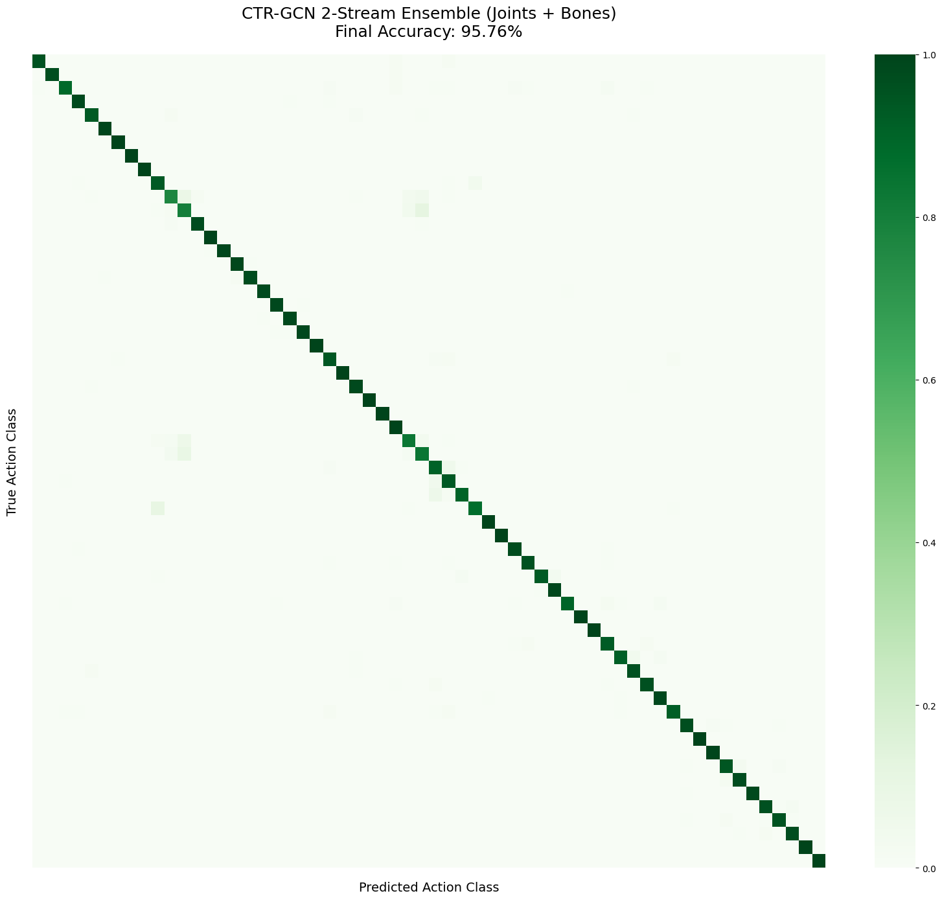
Fig. 1. Confusion matrix of the proposed model

Training Curves
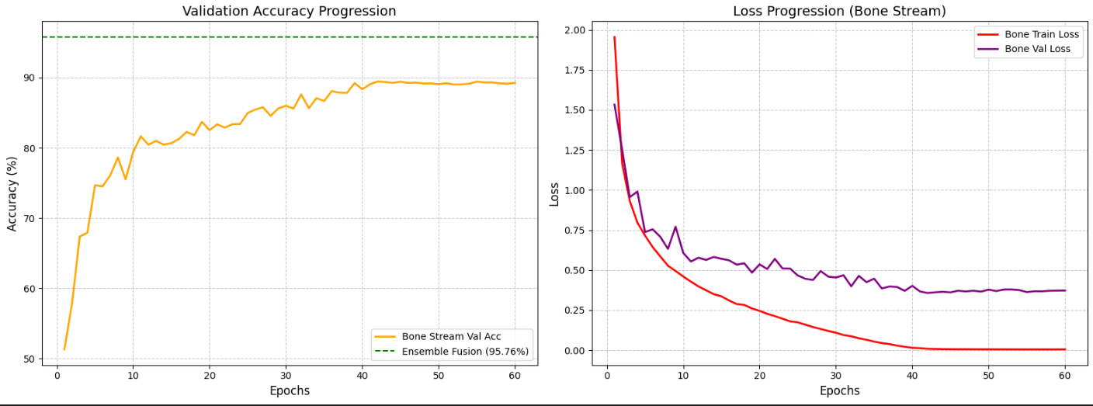
Fig. 2. Training curves of the proposed model

Comparison with Baseline Models
Table 5: Comparison of Proposed Model with Baseline Models
Model | Accuracy (%) | Precision (%) | Recall (%) | F1-Score (%) | Notes
ST-GCN | 76.8% | 79.8% | 76.8% | 76.1% | Baseline GCN
2s-AGCN | 73% | 75% | 73% | 73% | Adaptive graph + 2-stream
CTR-GCN (2 Stream) | 75% | 78% | 75% | 74% | Person-wise mean fusion (2 dimension)
MSG3D | 75% | 79% | 75% | 75% | Multi-scale spatio-temporal GCN
Pose Transformer | 84.32% | 85.05% | 84.32% | 84.32% | Transformer-based baseline
Proposed Model  (CTR-GCN 2-Stream Ensemble) | 95.76% | 95.85% | 95.77% | 95.77% | Joint + Bone fusion

Analysis and Discussion
The proposed CTR-GCN 2-stream ensemble achieves 95.76% accuracy with ~95.8% macro precision, recall, and F1-score, indicating not only high performance but also balanced learning across all 60 classes. The confusion matrix exhibits a strong diagonal dominance, confirming that most actions are correctly classified, with only minor confusion observed among semantically similar actions (e.g., actions with overlapping motion patterns). The training and validation curves show smooth convergence with steadily decreasing loss and no divergence, suggesting effective optimization and minimal overfitting due to appropriate regularization and data augmentation.
Compared to baseline models such as ST-GCN, 2s-AGCN, and MSG3D (typically ~73–77% accuracy), the proposed model demonstrates a significant performance gain, primarily due to the complementary nature of joint and bone streams and the channel-wise topology refinement mechanism, which enables more expressive spatial modeling. Additionally, the use of temporal convolution blocks enhances motion dynamics capture, further improving discrimination.
However, certain limitations remain. The model’s performance is still sensitive to the quality of input skeleton data, making it dependent on accurate pose estimation. Moreover, confusion between actions with subtle motion differences indicates that purely skeleton-based representations may lack contextual understanding. Despite these limitations, the results validate the effectiveness of multi-stream GCN architectures for robust skeleton-based HAR.

Conclusion
This work successfully demonstrates a high-performing skeleton-based HAR system using a 2-stream CTR-GCN, achieving 95.76% accuracy and outperforming multiple baselines. The combination of joint–bone fusion and adaptive graph learning proved effective for capturing complex motion patterns. While limitations such as pose dependency and closed-set constraints persist, the approach provides a strong foundation for future extensions toward more generalized and context-aware recognition systems.

References

[1] T. Nguyen, D. Pham, H. Vu, and T. Le, “A robust and efficient method for skeleton‐based human action recognition and its application for cross‐dataset evaluation,” IET Computer Vision, vol. 16, no. 8, pp. 709–726, Jul. 2022, doi: https://doi.org/10.1049/cvi2.12119.

[2] M. Cormier, Y. Schmid, and J. Beyerer, “Enhancing Skeleton-Based Action Recognition in Real-World Scenarios Through Realistic Data Augmentation,” Thecvf.com, pp. 290–299, 2024, Accessed: Apr. 26, 2026. [Online].Available: https://openaccess.thecvf.com/content/WACV2024W/RWS/html/Cormier_Enhancing_Skeleton-Based_Action_Recognition_in_Real-World_Scenarios_Through_Realistic_Data_WACVW_2024_paper.html
[3] J. Liu, A. Shahroudy, D. Xu, A. C. Kot, and G. Wang, “Skeleton-Based Action Recognition Using Spatio-Temporal LSTM Network with Trust Gates,” IEEE Transactions on Pattern Analysis and Machine Intelligence, vol. 40, no. 12, pp. 3007–3021, Dec. 2018, doi: https://doi.org/10.1109/tpami.2017.2771306.

[4] C. Dai, Y. Huang, and W.-C. Chien, “A sparse attack method on skeleton-based human action recognition for intelligent metaverse application,” Future Generation Computer Systems, Jan. 2023, doi: https://doi.org/10.1016/j.future.2022.12.043.

[5] M. Zhang, H. Yang, P. Li, and M. Jiang, “Skeleton-Based Action Recognition Based on Distance Vector and Multihigh View Adaptive Networks,” Computational Intelligence and Neuroscience, vol. 2021, pp. 1–10, Aug. 2021, doi: https://doi.org/10.1155/2021/1507770.

[6] H. Yu, “Human Action Recognition Algorithm Based on Highresolution Skeletal Images,” 2025 6th International Conference on Computer Engineering and Application (ICCEA), pp. 01–05, Apr. 2025, doi: https://doi.org/10.1109/iccea65460.2025.11103316.

[7] negarhdr, “GitHub - negarhdr/skeleton-based-action-recognition: This repository provides implementation of a baseline method and our proposed methods for efficient Skeleton-based Human Action Recognition.,” GitHub, 2025. https://github.com/negarhdr/skeleton-based-action-recognition (accessed Apr. 26, 2026).

[8] B. Yin et al., “Recognizing Skeleton-Based Actions As Points,” 2025 IEEE/RSJ International Conference on Intelligent Robots and Systems (IROS), pp. 21582–21589, Oct. 2025, doi: https://doi.org/10.1109/iros60139.2025.11247615.

